WOMEN IN FILM & VIDEO
WIFV.ORG

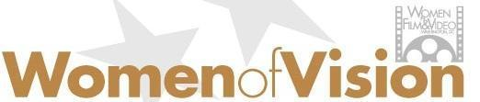

AWARDS CELEBRATION
April 3, 2025 @ 6:00 PM
National Museum of Women in the Arts
1250 New York Avenue NW
Washington, DC 20005

SPONSORSHIP PROPOSAL

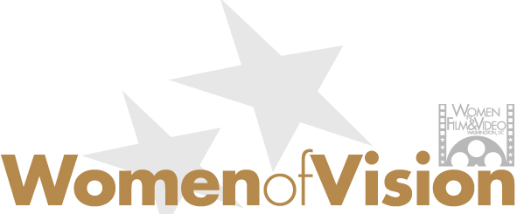

Join us for a very special evening honoring trailblazing women of vision. Past recipients have included a broad range of women working in broadcast news, feature films, documentaries, and advocacy work in positions in front of and behind the camera. All have enriched human experience through their storytelling. Their creative and technical achievements in media and the caliber of their work – on- and off-screen firmly establish them as WIFV role models and women to be honored. The 2025 Women of Vision honorees will be announced in late January.

The 2024 honorees were: Director/Writer/Actor Marielle Heller, Documentary Filmmaker E. Samantha Cheng, and Sylvia Bugg, PBS Chief Programming Executive and General Manager of General Audience Programming. The program was moderated by Ann Hornaday, Film Critic, The Washington Post. A full list of WIFV Women of Vision honorees is available here.

Your sponsorship will enable Women in Film & Video to continue providing educational programs, financial support, and networking opportunities to screen-based media makers in the Mid-Atlantic Region, as well as recognize and celebrate excellence in the industry.

2025 WOMEN OF VISION SPONSORSHIP OPPORTUNITIES
A unique opportunity to show your leadership and support of Mid-Atlantic media makers

$20,000 Platinum Sponsor (Exclusive)
      - Women of Vision presented by {Company Name}
      - 10 Tickets to Awards Ceremony with reserved seating
      - 10 Tickets to 45th Anniversary Programs held in 2025
      - Prominent branding on step-and-repeat
      - Recognition in all pre- and post-event publicity
      - On-stage recognition of sponsorship and photo with honorees
      - Educational sponsor for 2025 professional development programs
      - VIP Tour of the National Museum of Women in the Arts
$10,000 Gold Sponsorship
      - 8 Tickets to Awards Ceremony with reserved seating
      - 8 Tickets to 45th Anniversary Programs held in 2025
      - Prominent branding on step-and-repeat
      - Recognition in all pre- and post-event publicity
      - On-stage recognition of sponsorship
      - Networking sponsor for 2025
      - VIP Tour of the National Museum of Women in the Arts

$4,500 Silver Sponsorship
      - 4 Tickets to Awards Ceremony with reserved seating
      - 4 Tickets to 45th Anniversary Programs held in 2025
      - Prominent branding on step-and-repeat
      - Recognition in all pre- and post-event publicity
      - On-stage recognition of sponsorship
      - Includes sponsorship of two WIFV networking events
      - VIP Tour of the National Museum of Women in the Arts

$1,450 Bronze Sponsorship
      - 2 Tickets to Awards Ceremony with reserved seating
      - 2 Tickets to 45th Anniversary Programs held in 2025
      - Recognition in all pre- and post-event publicity
      - Includes sponsorship of one WIFV networking event
      - VIP Tour of the National Museum of Women in the Arts
Deadline for Sponsorships is March 15, 2025
Questions: Contact Melissa Houghton | 202.429.9438 | director@wifv.org

SPONSORSHIP RESPONSE FORM
DEADLINE: March 15, 2025

Yes! We would like to support Mid-Atlantic media makers by being a sponsor of Women in Film & Video’s 2025 Women of Vision Awards and the WIFV 45th Anniversary Programs.

LEVEL OF SPONSORSHIP (PLEASE CHECK ONE):
- Platinum Sponsor (Exclusive) $20,000
- Gold Sponsor $10,000
- Silver Sponsor $4,500
- Bronze Sponsor $1,450

- We cannot sponsor this year but would like to make a tax-deductible donation. Donation Amount: $_____________
****************************************************************************
COMPANY NAME: ______________________________________________________

CONTACT PERSON: ______________________________________________________

ADDRESS: __________________________________________________________

CITY: ____________________ STATE: ____________ ZIP: __________

PHONE: _____________________________________

EMAIL: _____________________________________

WEBSITE: _____________________________________

Sponsorship payments and donations can be made by credit card or check. Mail checks to:
Women in Film & Video (WIFV)
1200 18th Street NW, Suite 300, Washington, DC 20036
Make payment by credit card here
Questions: Contact Melissa Houghton | 202.429.9438 | director@wifv.org

